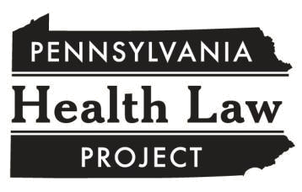
Medical Assistance Copayments

A Factsheet for Consumers

What if I cannot afford my medical co-pays?

If you cannot afford the co-pay, your pharmacist or doctor CANNOT refuse to give you medications or refuse to treat you.

Tell your provider if you cannot afford to pay. Your provider has to treat you, but you will still owe the provider the co-pay.

What if my provider won’t treat me because I can’t pay?

- Show the provider this factsheet.

- If the pharmacist or doctor still insists on the co-pay upfront, call your MA managed care plan (Keystone First, for example) and complain.

If you use the ACCESS card, call the Medical Assistance Call Center at (800) 537-8862, option 2, to complain.

- Call the Pennsylvania Health Law Project at (800) 274-3258 if you are still having problems.

Legal Authority

A provider participating in the program may not deny covered care or services to an eligible MA recipient because of the recipient’s inability to pay the copayment amount. This paragraph does not change the fact that the recipient is liable for the copayment, and it does not prevent the provider from attempting to collect the copayment amount.

55 Pa. Code § 1101.63(b)(8) (emphasis added)
This publication is intended to provide general legal information, not legal advice. Each person’s situation is different. If you have questions about how the law applies to your particular situation, please call the Helpline at 1-800-274-3258.

Copyright May 2020
The Pennsylvania Health Law Project is a nonprofit legal services organization.
www.phlp.org ▪ 1-800-274-3258

